Content:
- Types of Semiconductors
- Direct and Indirect Bandgap Semiconductors
- Hall Effect
- Construction and Working of Quantum Light Emitting Diodes (QLEDs)
- Construction and Working of Solar Cells
- Applications of Semiconductor Devices
- Concept of Harvesting Energy Devices (Piezoelectric & Thermoelectric Generators)
- Properties and Advantages of Graphene
Introduction:
The band that contains the highest energy electrons (or) valence electrons is termed as the valence band; the next higher energy band, which, under most circumstances, virtually unoccupied by electrons, is termed as the conduction band.
The energy corresponding to the highest filled state at zero Kelvin is called the Fermi Energy (EF). This represents the top-most filled electron energy state of the given material at zero Kelvin.
For semiconductors, all the states in the valence band are completely filled with electrons and there is no overlap between the valence band and the empty conduction band. This gives rise to a narrow energy band gap (<2eV) between the valence band and conduction band. The EF lies within the band gap.

TYPES OF SEMICONDUCTORS
A semiconductor is a solid which has the energy band similar to that of an insulator. It acts as an insulator at absolute zero and as a conductor at high temperatures and in the presence of impurities.
Based on the purity, semiconductors are classified into the following two types; viz

(i) Intrinsic semiconductor
(ii) Extrinsic semiconductor.

Intrinsic semiconductor | Extrinsic semiconductor
Intrinsic semiconductor is a pure semiconductor material like silicon or germanium | An extrinsic semiconductor has added impurities (dopants) to change its electrical properties
In intrinsic semiconductors, thermal energy moves electrons to the conduction band, creating electron-hole pairs | Extrinsic semiconductors can be N-type (more electrons) or P-type (more holes), based on the additives used.
At typical temperatures, intrinsic semiconductors exhibit low conductivity due to the constrained count of charge carriers generated by thermal effects | Extrinsic semiconductors have much higher conductivity than intrinsic ones because doping adds more charge carriers
Intrinsic semiconductors have a relatively large energy gap between their valence and conduction bands compared to extrinsic semiconductors. | Doping can also marginally alter the energy gap of extrinsic semiconductors, particularly in the presence of specific additives.
Intrinsic semiconductors aren’t very conductive, so they’re not used much in devices. But they’re important for understanding how semiconductors work | Extrinsic semiconductors are used in many electronics like transistors and solar cells because they have controllable high conductivity.

Direct and Indirect Bandgap Semiconductors
Depending on the shape of the band gap and as a function of the momentum K, one can classify the semiconductors as direct band gap semiconductors and indirect band gap semiconductors.
- Direct Bandgap Semiconductors
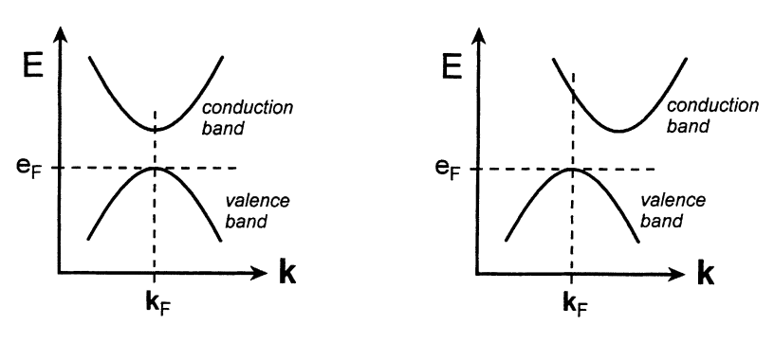
Direct band gap semiconductors(Fig), the conduction band minimum (Ec) and valence band maximum (Ev) energy occur at the same value of momentum K. Hence, it is possible for direct recombination of electron and hole, emitting a light photon of energy h. This type of light emission is not possible in indirect band gap semiconductors. Life time or recombination time of charge carriers is very less. Direct band gap semiconductor devices have much higher internal quantum efficiency. They are used to fabricate LED and Laser Diode. Examples for Direct band gap semiconductors are compound semiconductors, formed from III - V group elements and that formed from IV - VI group elements of the periodic table namely, Ga Al As, In Ga As P for (III - V), PbTe, Pb Sn Te for (IV - VI).
- Indirect Band gap Semiconductors:
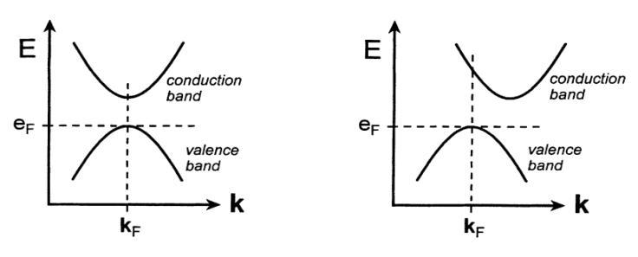
For indirect band gap semiconductors (Fig) the conduction band minimum and the valence band maximum occur at different values of momentum. To perform band-to-band recombination and to conserve momentum, it must involve a third particle called phonon (crystal lattice vibration), since the photon momentum is very small. Life time of charge carriers is more. Due to longer life time of charge carriers, they are used to fabricate the rectifier diodes and transistors which are used to make switches and integrated circuits.

Hall Effect:

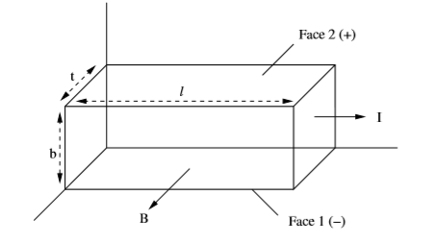
If a semiconductor carrying a current is placed in a transverse magnetic ﬁeld, an electric ﬁeld is produced in the semiconductor in a direction perpendicular to both the current and the magnetic ﬁeld. This phenomenon is called Hall eﬀect. The electric ﬁeld generated is called Hall ﬁeld and the corresponding voltage, Hall voltage.
Consider a rectangular slab of an n-type semiconductor sample. Let I be the conventional, current ﬂowing through the sample along positive x-direction, magnetic ﬁeld B is applied perpendicular to the direction of current ﬂow, say along positive z-direction. The eﬀect of the magnetic ﬁeld is to exert a force on the current carriers, namely electrons, ﬂowing in the negative x-direction. As a result of this force, the electrons will be forced downwards in the negative y-direction. This results in the lower face (Face 1 in the ﬁgure) becoming negatively charged with respect to the top face (Face 2). This constitutes the Hall ﬁeld E_{H}. This Hall ﬁeld will oppose the downward movement of electrons and equilibrium will be set up when
F_{E}= F_{B}
eE_{H} = Bev_{d}
where v is the drift velocity of the electrons.
E_{H} = Bv_{d}
v_{d}=E_{H}/ B
For a given semiconductor, the Hall coeﬃcient R_{H} is deﬁned as the Hall ﬁeld generated in the material per unit magnetic ﬁeld applied when the current density is unity.
i.e., R_{H} = E_{H}/BJ
J= nev_{d}
R_{H} = V_{H} I / B.d
The current density J can be expressed in terms of concentration of carriers n and their drift velocity as J = nev
From above equations, we get
R_{H} = Bv/Bnev = 1/ne

In the present case of n-type semiconductor,
R_{H} = −1/ne
since the Hall ﬁeld developed is in negative Y- direction. For a p-type semiconductor, RH will be positive and is given by
R_{H} = $1/pe$
Applications of Hall eﬀect:
Hall eﬀect can be used to identify the semiconductor type, namely n-type or p-type. It is useful in evaluating the carrier concentration. Knowing the conductivity, it is possible to ﬁnd the mobility of the carriers. Using a standard sample of known Hall coeﬃcient, it is possible to measure magnetic ﬁelds. This is the principle of construction of a gauss meter.
SOLAR CELL
It is a P-N junction diode which converts solar energy (light energy) into electrical energy.Common materials for solar cells include silicon (Si), Gallium Aresnide (GaAs), Indium Arsenide (InAs) and Cadmium Arsenide (CdAs). The most common is silicon.
Construction
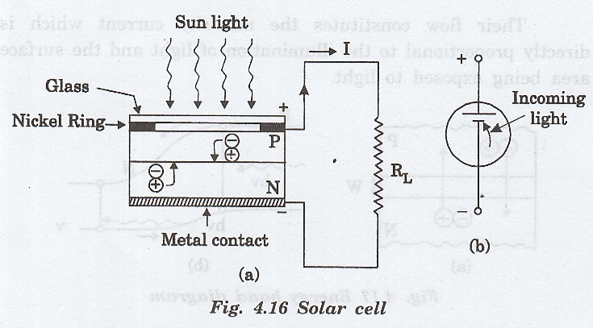
It consists of P-N junction diode made of Silicon (fig. a). The P-N diode is packed in a can with glass window on top such that light may fall upon P and N type materials. The symbol of the solar cell is shown in fig. b. The inward arrow indicates the incoming light.

The thickness of the P-region is kept very small. Therefore, electrons generated in P region can diffuse to the junction before recombination takes place. The thickness of N-region is also kept small to allow holes generated near the surface to diffuse to the junction before they recombine.
A nickel ring is provided around the P-layer which acts as the positive output terminal. A metal contact at the bottom serves as the negative output terminal.

Working
When light radiation from sun falls on the P-N junction diode, the photon energy is sufficient to break the covalent-bond and produce electron-hole pair. Thus, electron-hole pairs are generated in both P and N sides of the junction. These electrons and holes reach the depletion region by diffusion (fig.a) and they are separated by the strong barrier electrical field existing there. The minority carrier electrons in the P-side cross the barrier potential to reach N-side and the holes in N-side move to the P-side (fig. b).
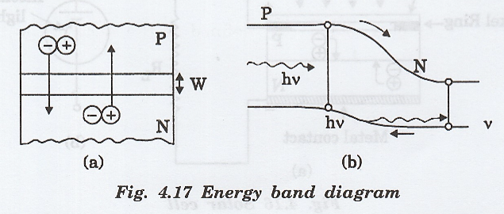
Their flow constitutes the minority current which is directly proportional to the illumination of light and the surface area being exposed to light. The electrons and holes are accumulated on the two sides of the junction. Once the newly created holes reach the p-type side, they cannot cross back over the junction due to the barrier potential. This separation of electrons and holes across the p-n junction allows it to function like a small battery cell.
A voltage is set up which is known as photo voltage. If we connect a small load across the junction, there will be a tiny current flowing through it.
This leads to an open circuit voltage V_{oc} which is a function of illumination.The open-circuit voltage produced for a silicon solar cell is typically 0.6 volt and the short-circuit current is about 40 mA/cm in bright noon day sun light.

V - I Characteristics
The V-I characteristics of the solar cell, corresponding to different levels of illumination is shown in fig. The maximum power output is obtained when the solar cell is opened at the knee of the curve.
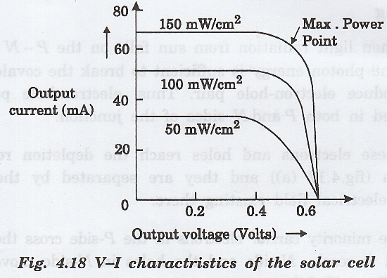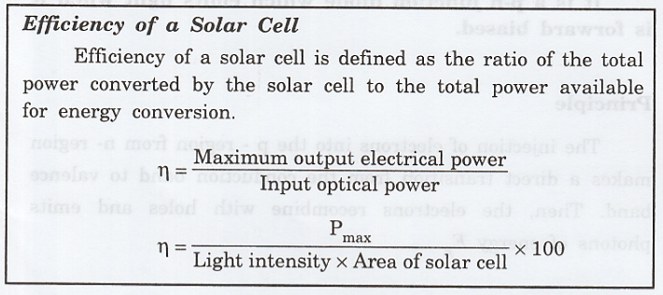

Advantages:
1. The solar cell operates with fair efficiency.
2. It has unlimited life.
3. It can be mass produced.
4. It has a high power capacity per weight.
5. Its size is small and compact.
Disadvantages:
Solar energy is not available round the clock. It cannot be obtained during night time.
Uses
i. Solar cells are used in satellites and space vehicles to supply power to electronic and other equipment’s and to charge storage batteries.
ii. They are used to give power to the calculators and watches.
iii. They are used to provide commercial electricity.
iv. It can be used in spacecraft to provide electrical energy.

- Solar Cell Definition: A solar cell (also known as a photovoltaic cell) is an electrical device that transforms light energy directly into electrical energy using the photovoltaic effect.
- Working Principle: The working of solar cells involves light photons creating electron-hole pairs at the p-n junction, generating a voltage capable of driving a current across a connected load.
- Construction Details: Solar cells consist of a thin p-type semiconductor layer atop a thicker n-type layer, with electrodes that allow light penetration and energy capture.
- Material Characteristics: Essential materials for solar cells must have a band gap close to 1.5 ev, high optical absorption, and electrical conductivity, with silicon being the most commonly used.
- Practical Uses: Solar cells power devices from small calculators and wristwatches to large-scale applications in spacecraft, highlighting their versatility and growing importance in renewable energy systems.
Criteria for Materials to be Used in Solar Cell
Must have band gap from 1ev to 1.8ev.
It must have high optical absorption.
It must have high electrical conductivity.
The raw material must be available in abundance and the cost of the material must be low.

Applications of Semiconductor Devices:
Semiconductors are essential components in modern electronics and have a wide range of applications. Here are some key areas where they are used:
- Transistors: Fundamental building blocks for amplifiers, switch, and signal processing in computers and other electronic devices.
- Diodes: Used for rectification in power supplies, signal demodulation, and as protection devices against voltage spikes.
- Integrated Circuits (ICs): Found in virtually all electronic devices, including microprocessors, memory chips, and system-on-chip (SoC) designs.
- Solar Cells: Photovoltaic cells convert sunlight into electricity, playing a crucial role in renewable energy technologies.
- LEDs: Light-emitting diodes are used for displays, indicators, and general lighting, known for their energy efficiency and longevity.
- Sensors: Employed in various types of sensors, including temperature sensors, photodetectors, and pressure sensors, used in consumer electronics and industrial applications.
- Power Electronics: Used in inverters, converters, and power supplies to manage electrical energy efficiently, critical in renewable energy systems and electric vehicles.
- Communication Devices: Found in radios, televisions, and networking equipment, enabling wireless and wired communication technologies.
- Consumer Electronics: Integral to smartphones, tablets, gaming consoles, and home appliances, driving advancements in technology.
- Automotive Applications: Used in control systems, infotainment, and safety features like advanced driver-assistance systems (ADAS).
Properties and Advantages of Graphene:

Graphene is a single layer of carbon atoms arranged in a two-dimensional honeycomb (hexagonal) lattice. It’s essentially a sheet of carbon atoms that’s only one atom thick, making it the thinnest and lightest material known. Despite being so thin, graphene is incredibly strong, flexible, and possesses unique electronic, thermal, and optical properties.

Properties of Graphene
- High Electrical Conductivity
Graphene’s atomic structure allows electrons to move through it with very little resistance, which is essential in electronics. Unlike traditional materials, electrons in graphene behave almost like they’re weightless, moving at extremely high speeds (close to the speed of light within the material). This makes graphene ideal for ultra-fast electronic devices, potentially even replacing silicon in future technology.
- Mechanical Strength
The strong covalent bonds between carbon atoms give graphene an extraordinary tensile strength of about 130 gigapascals (GPa), making it one of the strongest materials ever discovered. For comparison, steel typically has a tensile strength of around 0.4 to 1 GPa. This impressive strength is helpful for applications requiring durable, lightweight materials, such as in aerospace or construction materials.
- High Thermal Conductivity
Graphene’s structure allows it to conduct heat effectively, with a thermal conductivity of around 5,000 watts per meter per Kelvin (W/m·K). This property helps prevent overheating in electronic devices and batteries, where managing excess heat is crucial..
- Optical Transparency
Graphene’s single-atom thickness results in minimal light absorption, making it nearly transparent. It absorbs only about 2.3% of light, which is very low compared to other materials. This transparency, combined with high conductivity, makes graphene ideal for transparent touch screens, OLED displays, and photovoltaic cells in solar panels.
- Flexibility and Thinness
Because it’s only one atom thick, graphene is incredibly lightweight and flexible, allowing it to bend, twist, and stretch without breaking. This property is particularly useful for flexible and foldable electronic devices, such as next-generation smartphones, tablets, or wearable electronics, where flexibility is necessary without compromising strength.
- High Surface Area
A single gram of graphene has an area of over 2,500 square meters. This high surface area makes it an excellent candidate for applications in energy storage and chemical sensors, as it offers a larger area for reactions or storage within a small physical space. For instance, in batteries, a high surface area can improve energy storage capacity and charge/discharge efficiency.
- Impermeability
Graphene is essentially impermeable to gases and liquids, meaning that even the smallest gas molecules cannot pass through it. This makes it an effective barrier for coatings that prevent corrosion or degradation and as a membrane in filtration and separation processes (like water desalination), where selective permeability is essential.
- Biocompatibility
Graphene has shown potential for safe integration with biological systems, which is critical for medical applications. This biocompatibility means that graphene can be used in drug delivery systems, where drugs can be attached to graphene and released into the body in a controlled manner, as well as in sensors and implants that interact directly with human tissues.

Advantages of Graphene
- Enhanced Electronics
Graphene’s fast electron movement allows for quicker response times in electronic components, potentially enabling the creation of extremely fast processors. Graphene transistors could be much faster than those made of silicon, leading to faster computers and new generations of ultra-responsive sensors and chips.
- Better Energy Storage
In batteries and supercapacitors, graphene’s high conductivity and surface area can increase energy density (storage capacity), reduce charging times, and extend overall lifespan. For electric vehicles, this means quicker charging and longer-lasting batteries, while for consumer electronics, it means devices that hold charges longer.
- Environmental Applications
Graphene’s impermeability and high surface area allow it to act as a filter, capturing contaminants or filtering water at the molecular level. In desalination, graphene membranes can remove salt from seawater more efficiently than traditional methods, providing clean drinking water in an eco-friendly way. Similarly, it can capture pollutants from air, helping to purify environments and reduce waste.
- Biomedical Innovations
Graphene’s biocompatibility allows it to interact safely with biological systems, making it suitable for medical devices and implants. In drug delivery, graphene can carry drugs to specific cells or tissues, releasing the medication directly where it’s needed, minimizing side effects and increasing treatment effectiveness. In biosensors, it can detect specific molecules or pathogens, enabling early disease detection.
- Lightweight and Durable Materials
Graphene’s strength and lightweight nature make it ideal for applications in transportation, where reducing weight can improve fuel efficiency. For example, using graphene-reinforced composites in airplanes or cars could lead to lighter, stronger structures that consume less fuel and have enhanced durability, improving performance and safety.
- Efficient Thermal Management
Graphene’s high thermal conductivity helps dissipate heat in electronic devices. This is crucial for devices like smartphones, laptops, and high-performance GPUs, which generate significant heat. Efficient heat dissipation prevents overheating and extends the lifespan of these devices, making graphene valuable in thermal management.
- Flexible and Wearable Electronics
Graphene’s flexibility allows it to be integrated into wearable technology, such as fitness trackers or medical monitors, that need to conform to the body’s shape without losing functionality. This flexibility is also beneficial for foldable screens and electronic textiles, pushing the boundaries of modern device design.
- Improved Sensors
Graphene’s high sensitivity to environmental changes makes it ideal for sensors that need to detect minute amounts of gases or biomolecules. For instance, a graphene-based sensor could detect harmful gases in the air at very low concentrations, providing early warning of pollution or toxic exposure. In medical settings, it can detect biomarkers for diseases, enabling early diagnosis and potentially life-saving interventions.

